**Stakeholders:**

**Classification and Justification** (Wikipedia, 2025)**:**

**Primary** (Indeed, 2025)**:**

* **Development Team:** They Build and maintain the system thus it’s reception directly affects them.
* **Students Group A (which use the app directly):** They are able to use the system directly as a new means of studying and reviewing their study material.
* **Teachers:** They will be able to use the ai to make making quizzes and exams for the materials they teach faster and easier.
* **College & University Professors:** They will be able to use the ai to make making quizzes and exams for the materials they teach faster and easier.

**Secondary** (Indeed, 2025)**:**

* **Students Group B (which don’t use the app directly):** They may have to take quizzes and exams made by the app which were made by the app.
* **Educational Bodies:** While they may not interact with the system directly, they may need to license the system or buy the right to use it.

**Tertiary** (Chron - Small Business, 2012)**:**

* **Textbook publishers:** The system may cause reduced demands for premade question banks which will negatively affect their sales.
* **Educational Researchers:** they may need to study how the ai usage affects affect assessment quality and student learning outcomes.
* **Educational Book Sellers Libraries:** If teachers and schools rely more on AI-generated quizzes, they may buy fewer printed quiz books or use fewer library resources for test prep.

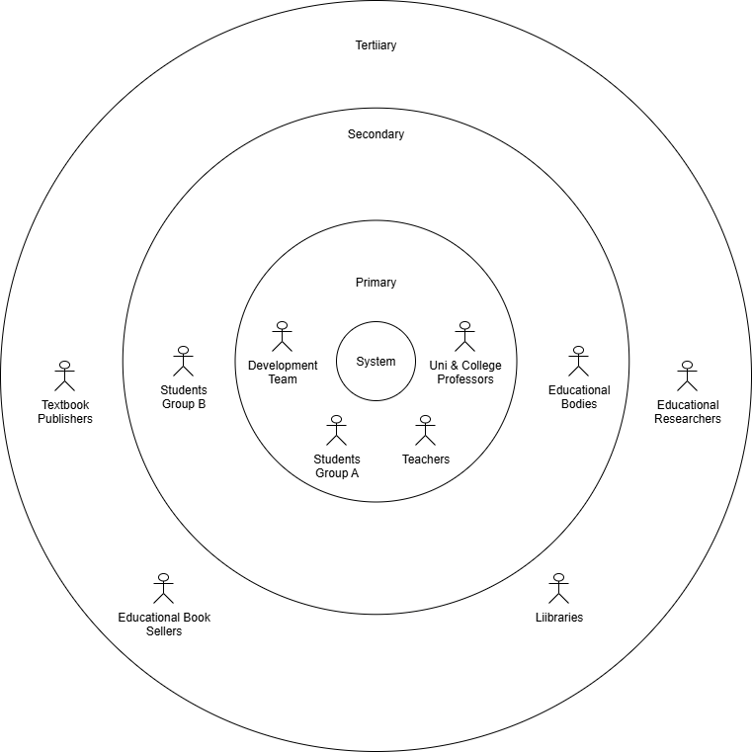Figure 1: A Stakeholders Onion Diagram similar to the Template from (Creately,2025)

**References:**

* **Wikipedia:** <https://en.wikipedia.org/wiki/Stakeholder_analysis?utm_source=chatgpt.com#Stakeholder_types>
* **Indeed:**
* <https://www.indeed.com/career-advice/career-development/primary-and-secondary-stakeholders?utm_source=chatgpt.com>
* **Chron-Small Business:**<https://smallbusiness.chron.com/definition-tertiary-stakeholder-37756.html?utm_source=chatgpt.com>
* **Creately:**<https://creately.com/diagram/example/jqq5komr6/stake-holder-onion-diagram>